# Bindicator Instruction Sheet

The Bindicator is an indicator that lights up to tell you what bins to put out this week at your address. This is based on the current DCC website and could break if/when DCC update their site code. It does this by running a program on a little microcontroller connected to some LEDs. The microcontroller connects to your WiFi, and through that to the DCC website, passing your street address, and reading the response. It then uses this response to light the appropriate colours.

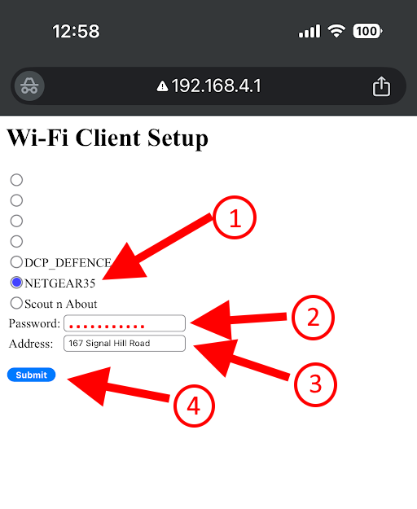Setup:

1. Plug in the Bindicator to a USB power supply via the USB-C port at the back
2. On your phone (or laptop), go to Settings/Wifi and connect to the “**Bindicator”** network, with a password of *bindicator*
3. Then open a browser, and go to **192.168.4.1**
   1. You should see your home wifi name on this list – tap the radio button beside it
   2. Enter your home wifi password
   3. Enter your home address just as number and street name as per example only.
   4. Then tap the SUBMIT button.

All going well, this will save the wifi credentials and address, then restart the Bindicator, which should then connect to your wifi, and grab the info for your address from the DCC website and light up with either **Green/Yellow/Green/Yellow** or **Green/Red/Blue/Green** .

Notes:

* When turned on it will be white then cycle through dark blue/green until it connects to wifi
* If the address is not recognised by the DCC site, the Bindicator will light up **Red/ White/ Red/ White.**
* The address doesn’t have to be **your** home address, just a *VALID* address somewhere on your street, so “1 Jones Street” is fine as long as there is an actual 1 Jones Street that the DCC has on its records.

Troubleshooting:

Ok, firstly this isn’t a commercial or saleable product, just a home project so please bare with. It may take a few goes to connect to the initial Bindicator 2.4Ghz network depending on other WiFi networks in the area, and can take from 2-30 seconds when powered on to connect to your wifi once configured. It can also be fixed with turning it off & on again like many IT issues! 😁

* In the WiFI Client Setup process it may give an error message *Wi-Fi not connected* or *parameter error*. Easiest fix is to power off, wait 5 seconds, power on and restart.
* If you get the **Red/ White/ Red/ White** sequence it means there’s something wrong with the address. Only way to fix that is via the initial settings screen so you *first need to be* ***out of range of your home wifi***, repeat the process in #3 above, and enter an updated address. It won’t connect but does update the address. Then power it off, bring it back in range of your home Wi-Fi and it should work.

Code is Open Source: <https://github.com/GSVNoFixedabode/BinDaycator>

Original idea: <https://jaywll.co/tag/bindicator/> (Code re-developed from scratch for Dunedin City Council site)

3D print model: https://www.printables.com/model/794978-bindicator-remix-for-esp32-c3-zero